**FAITH JUNIOR SCHOOL-KASENGE**

**PRIMARY FIVE EXAMS**

**SOCIAL STUDIES MID TERM THREE 2023-SET 2**

***Time Allowed: 2 Hour 15 minutes***

**Name:_______________________________________**

**Read the following instructions carefully.**

1. This paper has **two** sections **‘A’ and ‘B’**
2. Section A has 40 questions (40 marks)
3. Section B has 15 questions (60 marks)
4. Attempt **ALL** questions.
5. All answers to both sections A and B **MUST** be written in the spaces provided.
6. All answers **MUST** be written using a black or blue ball-point pen or ink. Diagrams should be drawn in pencil.
7. Unnecessary alteration of work may lead to loss of marks.
8. Any handwriting that cannot easily be read may lead to loss of marks

|  |  |  |
| --- | --- | --- |
| **FOR EXAMINERS’ USE ONLY** | | |
| **QN. NO.** | **MARKS** | **TOTAL MARKS** |
| **1 – 10** |  |  |
| **11 – 20** |  |  |
| **21 – 30** |  |  |
| **31 – 40** |  |  |
| **41 – 50** |  |  |
| **51 – 55** |  |  |
| **TOTAL** |  |  |

**SECTION ‘A’ – 40 marks**

1. Name any **one** main point of a compass.

_______________________________________________________________________

1. Write **one** lake in Uganda crossed by the Equator.

________________________________________________________________________

1. State any **one** role of a head-teacher in a school. _______________________________________________________________________
2. Draw a map symbol of a hill.
3. Why do Karimajongs move from one place to another?

__________________________________________________________________________________________________________________________________________________

1. Which type of coffee is grown on the slopes of Mountain Elgon? _______________________________________________________________________
2. Name **one** interlacustrine kingdom in Uganda. _______________________________________________________________________
3. State **one** way crop growing can be made possible in the leeward side of a mountain. _______________________________________________________________________
4. Why did Egypt attempt to colonize Uganda?

__________________________________________________________________________________________________________________________________________________

1. Name the physical feature that attracted most explorers to Uganda.

_____________________________________________________________________

1. Why was the LEGCO formed in Uganda?

____________________________________________________________________________________________________________________________________________

1. Why does government discourage swamp drainage?

____________________________________________________________________________________________________________________________________________

1. Give any **one** cultural use of animals.

______________________________________________________________________

1. Who was the kabaka of Buganda by the time the 1900 Buganda agreement was signed?

____________________________________________________________________

1. What does the yellow colour on the Uganda National Flag symbolize

______________________________________________________________________

1. Name any **one** symbol of a nation.

______________________________________________________________________

1. Give **one** reason why most people in Uganda practice subsistence farming.

______________________________________________________________________

1. Write U.P.E in full.

______________________________________________________________________

1. Give **one** lesson you learn from the legend of Gipiir and Labong.

_____________________________________________________________________

1. How is grass useful to people?

______________________________________________________________________  
______________________________________________________________________

1. Which body in Uganda collects revenue for the government?

_____________________________________________________________________

1. Name **one** inland port found on Lake Victoria in Uganda.

______________________________________________________________________

1. In which direction does the sun set? ______________________________________________________________________
2. Name the basic need obtained from a school.

____________________________________________________________________

1. Mention any **one** product got from soft wood trees.

____________________________________________________________________

1. Give any **one** importance of social activities in your community.

_____________________________________________________________________

1. How does police keep law and order?

_____________________________________________________________________

1. What is a plateau?

____________________________________________________________________________________________________________________________________________

1. How was a dog useful to the early man?

____________________________________________________________________

1. Name **one** traditional cash crop grown in Uganda.

____________________________________________________________________

1. What is deforestation?

____________________________________________________________________

1. Why are most game parks located in Savannah grassland?

____________________________________________________________________________________________________________________________________________

1. State **one** negative contribution of the Arabs in Uganda.

______________________________________________________________________

1. Why is Prime meridian sometimes called Greenwich?

____________________________________________________________________________________________________________________________________________

1. How is Uganda and South Sudan similar in terms of geographical location?

____________________________________________________________________________________________________________________________________________

1. Why is tourism called an industry?

____________________________________________________________________________________________________________________________________________

1. Name the process for the formation of Lake Victoria.

______________________________________________________________________

1. Give any **one** Bantu tribe in Uganda.

______________________________________________________________________

1. What is climate?

____________________________________________________________________________________________________________________________________________

1. Mention the special means of transport used by Arabs to come to East Africa.

____________________________________________________________________

***SECTION B (60 Marks)***

1. Study the map of Uganda below and use it to answer the questions that follow.

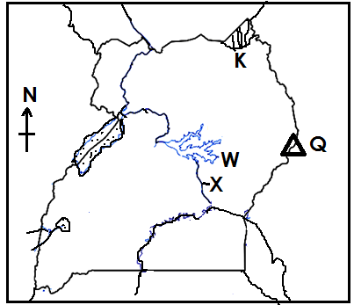

1. Name the highest peak of mountain marked Q.

__________________________________________________________________

1. Name the game park located in area marked K.

__________________________________________________________________

1. Why is feature W swampy?

____________________________________________________________________________________________________________________________________

1. Name the part of the Nile marked X.

__________________________________________________________________

1. (a) Who signed the 1900 Buganda agreement on behalf of Buganda?

___________________________________________________________________

1. Why was Kabaka Daudi Chwa unable to sign the above agreement?

__________________________________________________________________

1. State any **two** terms of the 1900 Buganda agreement.
2. ____________________________________________________________
3. ­­­­­­­­­­­­­­­­­­­­­­­_­­­­­­­­­­­­­­­­­­­­­­­­­­­­___________________________________________________________
4. (a) What is transport?

_________________________________________________________________

_________________________________________________________________

(b) State any **two** means of water transport.

(i) ____________________________________________________________

(ii) ____________________________________________________________

(c) Mention **one** cause of accidents on lakes.

_________________________________________________________________

1. (a) Give any **two** elements of weather.
2. _________________________________________________________________
3. _________________________________________________________________

(b) Mention any **two** weather instruments.

(i) ___________________________________________________________

(ii) ___________________________________________________________

1. (a) Mention any **one** symbol of a clan.
2. ____________________________________________________________

(b) State any **one** role of a clan head.

_________________________________________________________________

(c) Give **two** examples of cultural practices.

(i) _____________________________________________________________

(ii) ____________________________________________________________

1. Fill in the table below correctly.

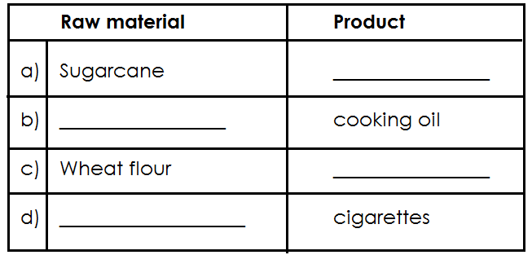

1. (a) What is fishing?

_____________________________________________________________________

_____________________________________________________________________

(b) Mention any **two** modern ways of preserving fish.

(i) _________________________________________________________________

(ii) _________________________________________________________________

(c) Give any **one** use of fish to people.

____________________________________________________________________

1. (a) Which type of rainfall is received around lakes and rivers?

____________________________________________________________________

b) How is rainfall important to people?

__________________________________________________________________________________________________________________________________

c) Which type of clouds give us rain?

_________________________________________________________________

d) Mention **one** human activity that leads to low rain formation.

_________________________________________________________________

1. Match the following correctly.

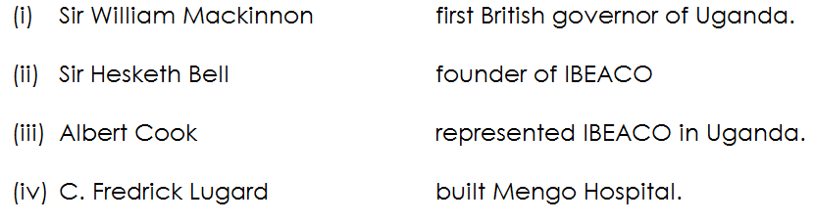

(i) ____________________________________________________________

(ii) ____________________________________________________________

1. ____________________________________________________________
2. ____________________________________________________________
3. ____________________________________________________________
4. (a) Name any **two** crops grown for food in Uganda.
5. _________________________________________________________________
6. _________________________________________________________________

(b) Give any **two** examples of traditional cash crops grown in Uganda.

(i) __________________________________________________________

(ii) __________________________________________________________

1. (a) What is a resource?

____________________________________________________________________________________________________________________________________________

(b) Give any **one** example of non-renewable resource.

(i) ____________________________________________________________

(c) Mention **two** uses of land to people.

(i) ____________________________________________________________

(ii) ____________________________________________________________

1. (a) What is a kingdom?

___________________________________________________________________

___________________________________________________________________

(b) Name the earliest kingdom to be formed in Uganda.

(i) ____________________________________________________________

(c) Give **two** importance of kingdoms in our community.

(i) ____________________________________________________________

(ii) ____________________________________________________________

1. Explain the following terms as used on rivers;
2. River south;

__________________________________________________________________________________________________________________________________

1. Confluence;

__________________________________________________________________________________________________________________________________

1. River mouth;

__________________________________________________________________________________________________________________________________

1. Distributary;

__________________________________________________________________________________________________________________________________

1. (a) What is dairy farming?

______________________________________________________________________________________________________________________________________

b) Give any one product from a dairy farm.

___________________________________________________________________

c) Mention **two** problems faced by farmers in Uganda.

(i) _________________________________________________________________

(ii) _________________________________________________________________

1. (a) What is rural – urban migration?

__________________________________________________________________________________________________________________________________________

(c) Give **three** reasons why people migrate from villages to town.

(i) _________________________________________________________________

(ii) _________________________________________________________________

(iii) _________________________________________________________________

***E N D***